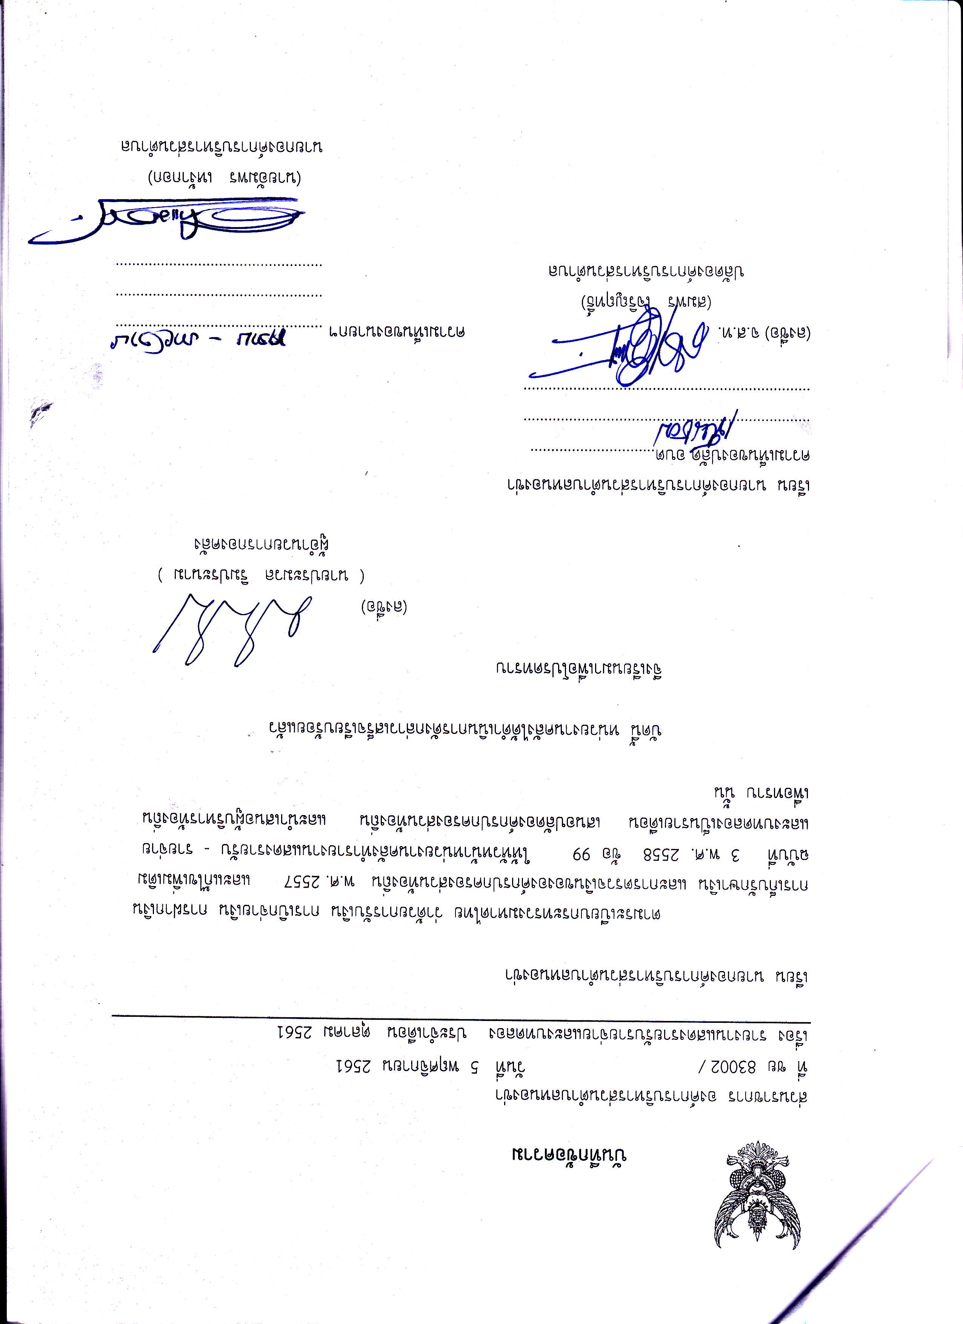

gNtUNLPgL4gNgLUU}GU
BLN

(uGUrlktl
sMtr€BLru)

unLUnLp gLKcrusLu tdN0r4uru

'r 'p'u (c&bu)

tn,bGnt4gnL6nLpgL!(gngtuub0uBLn
rotp
ruBgt

SUIJNOUgLUBLNLOft
ft aft
- mrruas[tlBs uLtrBs[LBLn )
/Yw (o&Nu,
fttgr t,gnlcMlrltnB91ND
's|PPF

t911 BOgft B g1 Ugpl LLUU$!dSLUrurul tL4tdl $UUttLlB Lnt{ nuft

,
rur ftLgr^oNrl

nglGlAsLklgnftonetup*un
BLUBLS -
rugNor rurp$0srJU[rsuu[otd^uDorupl
ruor4lBrsnB,*inr*no^r,

mBLsbrdprnLlBLgLr^$^uunLbBLnltLflkrlssl
66 otb gggz .u.M
t
snlrB

Itrdlttu,ltuLu1laUll
Lggz'w.vL rugbGunLDNoguuncuulGlGl],nNuLgr{sLuAutl
nblL6[utrrulgru

lxsl u Llr s
Lu nbl B L u u nl g LU ruN ft*S
L U B L^t4L L B rA}4 L k$tl
LS r^ a g u l B nl B g tt L rd

LtubonnunLl4nLpsLktsnsLUU]GUBLn
nBsl

I99Z tSUrUiO nOgruuerp beuut^n]AsllBL&BLgmBLENr4ErnL]BLs
S0g1

I99z ruBtulubr'r 9
Snl
- zooeg ntu
W

I
LtuNonlrurutunLpgLmgngLUU[0 gLUtuLgrXLp

ntgu@fru
6nru
PF

